📊 EURUSD (H1) — Decision
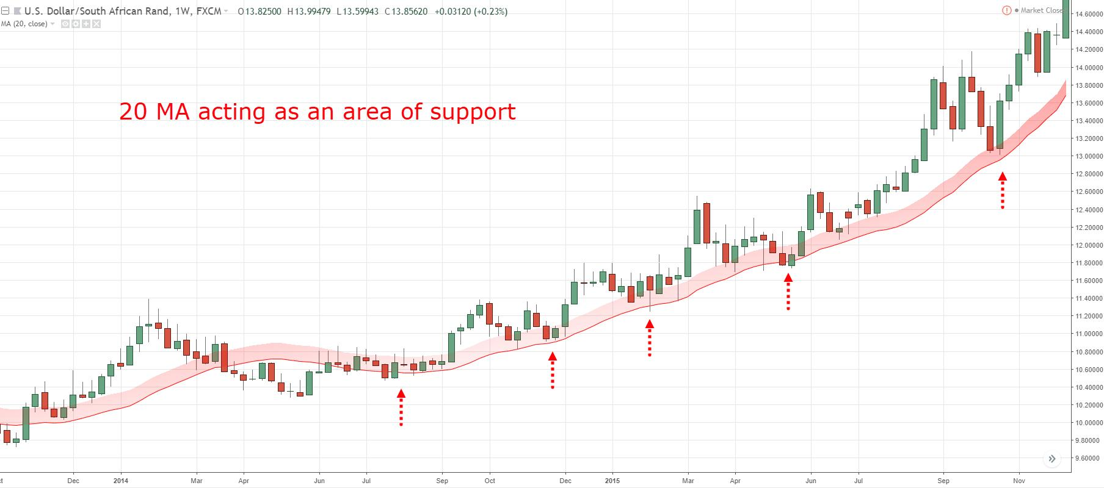
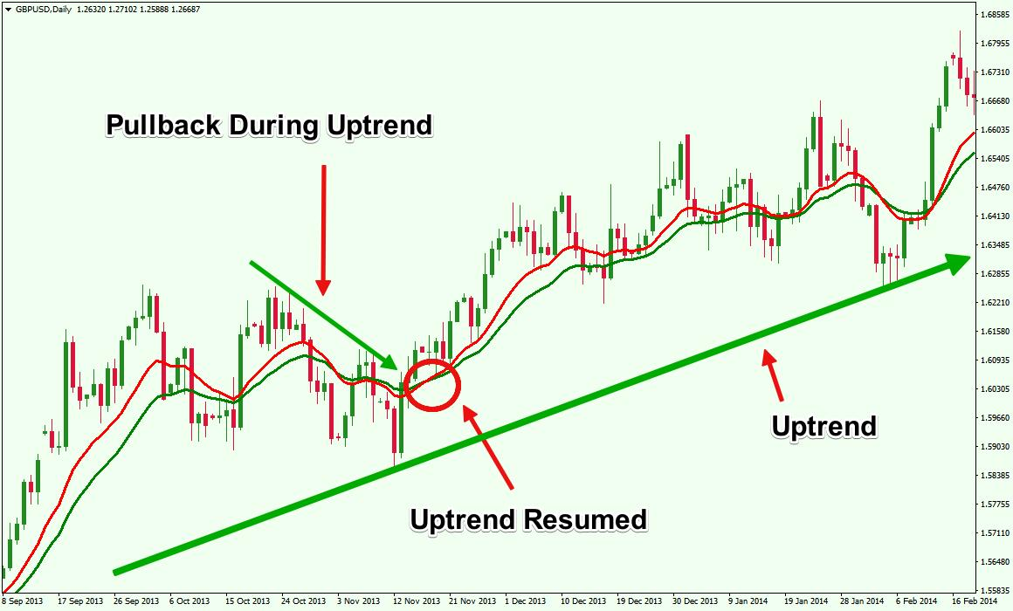
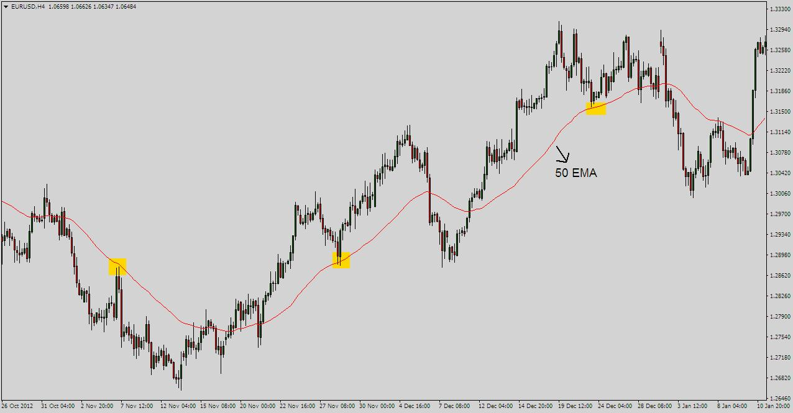
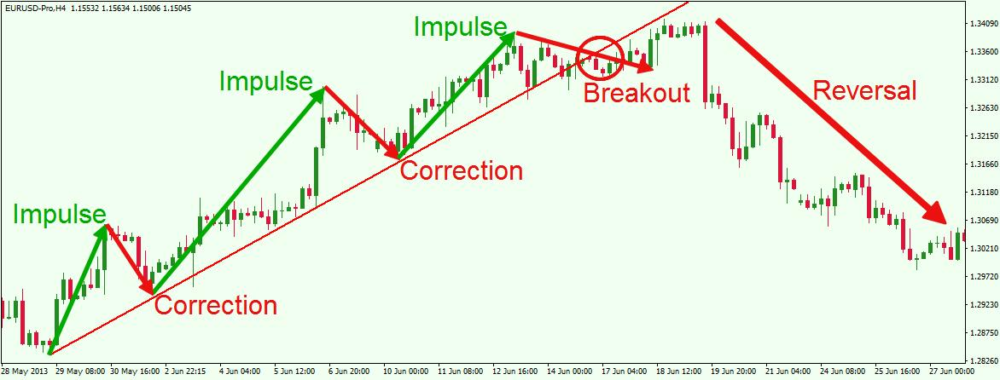
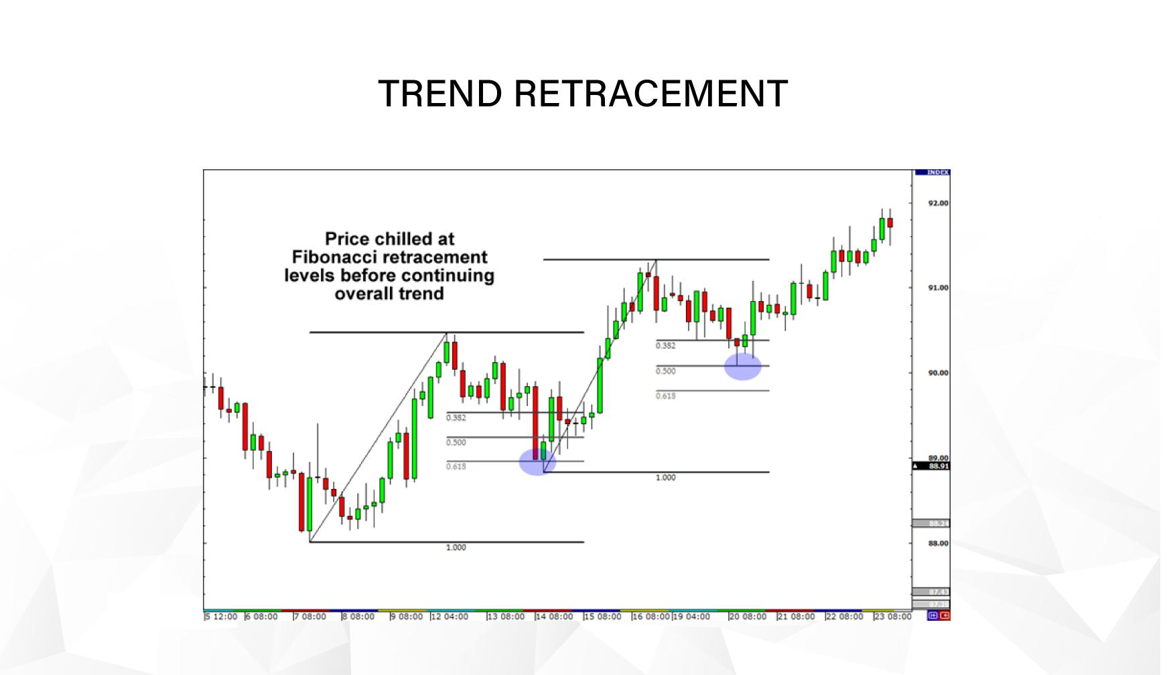
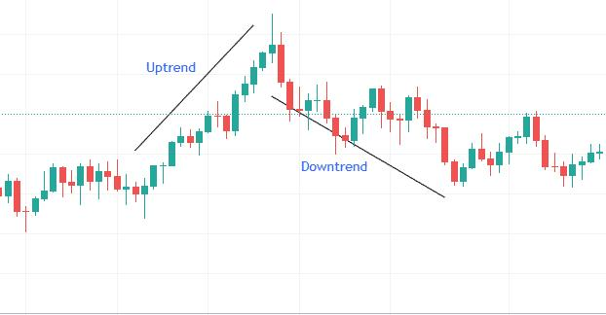
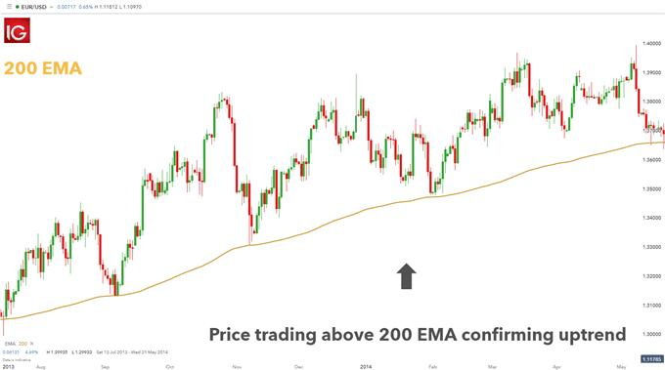

🔍 What I’m Seeing
- Market was bearish, then shifted to bullish
- EMA 50 (red) has crossed above EMA 200 (blue) → trend shift ✅
- Price recently made a strong push up
- Now price is pulling back to EMA zone
👉 This is a bullish trend with a pullback

⚠️ Current Situation
Right now:
- Price is dropping slightly
- Testing EMA 50 / EMA 200 zone
👉 This is not a sell signal — it’s a retracement

🎯 Smart Trade Plan

🟢 BUY Setup (Best Option)
Wait for:
- Price to hold above EMA 50
- A strong bullish candle (rejection from the EMA zone)
👉 Then BUY

🔴 SELL Setup (Only if this happens)
Sell ONLY if:
- Price breaks below EMA 200
- Trend flips (lower low forms)
👉 Right now → NOT confirmed

❌ Avoid
- Selling during a pullback in an uptrend
- Entering before confirmation

🧠 EA Perspective
Your bot should:
- Look for BUY continuation
- Ignore SELL unless structure breaks

🔥 Final Answer
👉 Direction: BUY
👉 Action: WAIT for confirmation (pullback bounce)

If you want next:
I can upgrade your EA so it automatically detects pullbacks and enters at the perfect moment (this is where most profits come from).

